
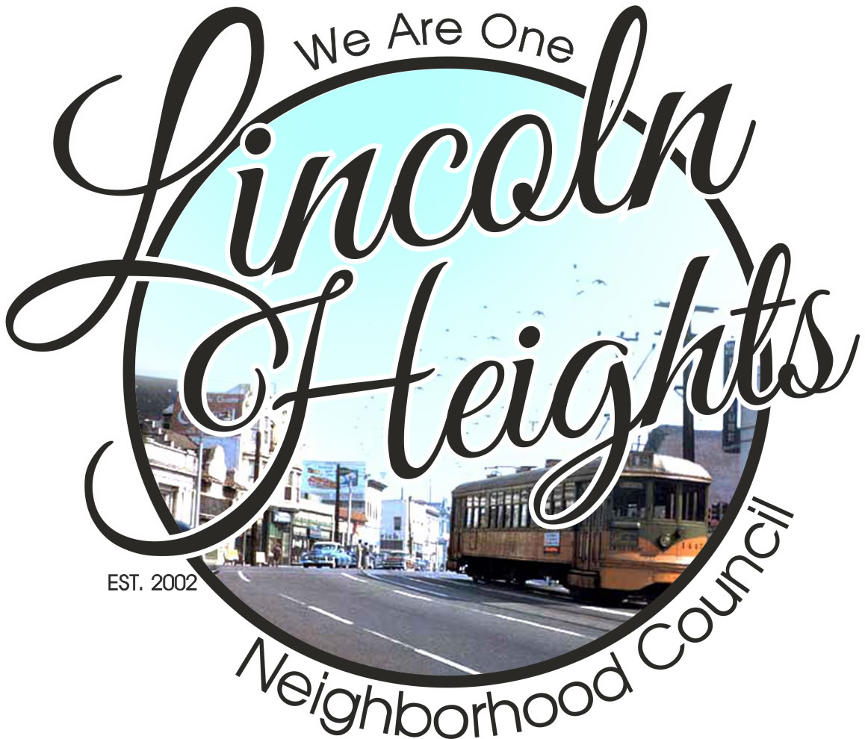

LINCOLN HEIGHTS NEIGHBORHOOD COUNCIL
15TH ANNUAL HOLIDAY PARADE & FESTIVAL

Dear Interested Participant:
The Lincoln Heights Neighborhood Council is hosting its 15th Annual Lincoln Heights Holiday Parade and Festival!
The Parade will be on Sunday, December 2, 2018 and will start at 11:00a.m at the corner of N. Broadway and Lincoln Park Avenue
If your group wishes to participate in the parade, you are asked to complete the attached application and send it in by November 2, 2018. You may fax, mail, email or deliver the application in person at the address on the entry form. Only the responsible contact person may sign the application entry form. The same person will sign in at the registration table on the day of the Parade. Upon receiving your completed application, the Committee will phone or email you to confirm your participation.
As in previous years, the council is inviting marching bands, drill teams, cheerleaders, dance groups, car clubs, individual antique or classic cars, floats, entertainers, Folklorico dancers, horses (must bring their own pooper scooper), clowns, specialty groups or acts. And as always, we will have dignitaries and VIP’s participate in the parade.
Sign in time for participants is at 9:30a.m. at the registration table by the Department of Motor Vehicles, 3529 North Mission Road. The parade will travel South on North Broadway for a mile and will end at the corner of Avenue 24 and North Broadway by the Bank of America.
At the conclusion of the parade, you are welcome to stay at the Bank of America parking for the Holiday Festival entertainment from 12p.m. to 3:00p.m, a snow slide for children, and a Santa’s booth for picture taking. Entertainment will also include children’s arts and crafts, games; face painting, Pizza and refreshments. This event is free to the community. Invite all your friends and family to the biggest event in Lincoln
Sincerely
Holiday Parade Committee: Chairperson: Vera Padilla CO Chairperson: Maria Palacio, Committee Members: Vicente Gonzalez, Vince Rosiles, Tameka Flowers, Theresa Velasquez, Esther Rosas, Belen Eller, Anthony Rocha.



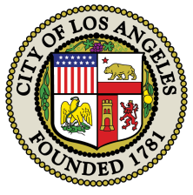
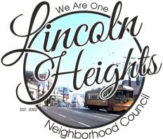
LINCOLN HEIGHTS HOLIDAY PARADE & FESTIVAL SUNDAY, DECEMEMBER 2, 2018 Participant line up starts at 9:30am 2018 OFFICIAL ENTRY FORM (Please complete one form for each entry)

Contact Name:______________________________________________Office Phone #:________________________
Cell #:____________________________Email:__________________________Fax:____________________________
Name of your entry:______________________________________________________________________________
Describe your entry:______________________________________________________________________________
How many in your group:_________Do you have a float?_________How many cars/trucks do you have?__________
How many horses do you have?__________How many pooper scoopers (required if horse entry)?_______________
What are the School or Group Colors?________________What is your mascot?______________________________
How long has current Director of School or group been in charge?_________________________________________
Alternate Contact person: Name_________________________Email_______________________Cell:____________
Please give us a little history of your group: Please completE-INFOMRATION NEEDED FOR THE PARADE ANNOUNCER _____________________________________________________________________________________________________________________________________________________________________________________________________________________________________________________________________________________________
_______________________________________________________________________________________________
ENTRY TYPE (CHECK ALL THAT APPLY): ____Band ____Drill Team____ Sports Team____ Color Guard____ Folklorico
___Antique/classic auto ____Car Club___ Motorcycle Group ____Float____ Equestrian ____Cheer____Dancers
____other
I hereby agree that the above is true as entered. In addition, my entry agrees to relieve and hold harmless the cCity of Los Angeles, event volunteers, the Lincoln Heights Neighborhood Council, and any of its officers or agenets from liability in connection with this event including liability for any loss, damage or injury resulting from participatioon in the event. I have read the RULES OF THE PARADE, have initialed each line item and agree to abide by them.
Printed Name:________________________________Signature:__________________________Date:___________
COMPLETED APPLICATION MUST BE RECEIVED BY FRIDAY, NOVEMBER 2,2018 Submit your application to: Vera Padilla Email: chaidez46@yahoo.com
Submission of application does not constitute acceptance
Rules of the Parade
(There is no fee to participate in the parade)

Ent
Entry Form Return Deadline November 2, 2018
All parade entries must be approved by the Lincoln Heights NC Holiday Parade Committee.
All entry forms must be in by November 2, 2017. Entry Applications will not be accepted on parade day.
Only Parade participants and official personnel are allowed on the Parade route.
Any activity which encourages or entices spectators to enter the Parade route is not allowed.
Pyramids and lifts may be performed at your own risk! (SIGNED WAIVER BY YOUR COACH)
Throwing candy or other gifts to spectators is not allowed! It may disqualify you form future parades.
It is recommended that all participants have breakfast before coming to the event.
It is recommended that all participants bring their own water to prevent dehydration.
We allow ONLY ONE Santa Claus in the Parade! The Parade Santa Claus has been selected.
Registration starts @9:30am at the corner of Mission Road/Lincoln Park Avenue
All motorized entries must have proof of insurance and a licensed vehicle driver.
Only the contact person on the day of parade may sign-in at the registration table.
Equestrian Entries: For the clean-up of your horses waste, you must have someone pick up the waste, a pooper scooper is recommended.
Signature of responsible individual________________________________________________________________
Print Name:_____________________________________________________Date:__________________________
Email________________________________________________________Cell______________________________
WE LOOK FORWARD TO YOUR PARTICIPATION
APPLICATION MUST BE RECEIVED BY: November 2 2018
ATTN: Vera Padilla-(323)236-0595 Email: chaidez46@yahoo.com

